Vögel in
Köln-Finkenberg
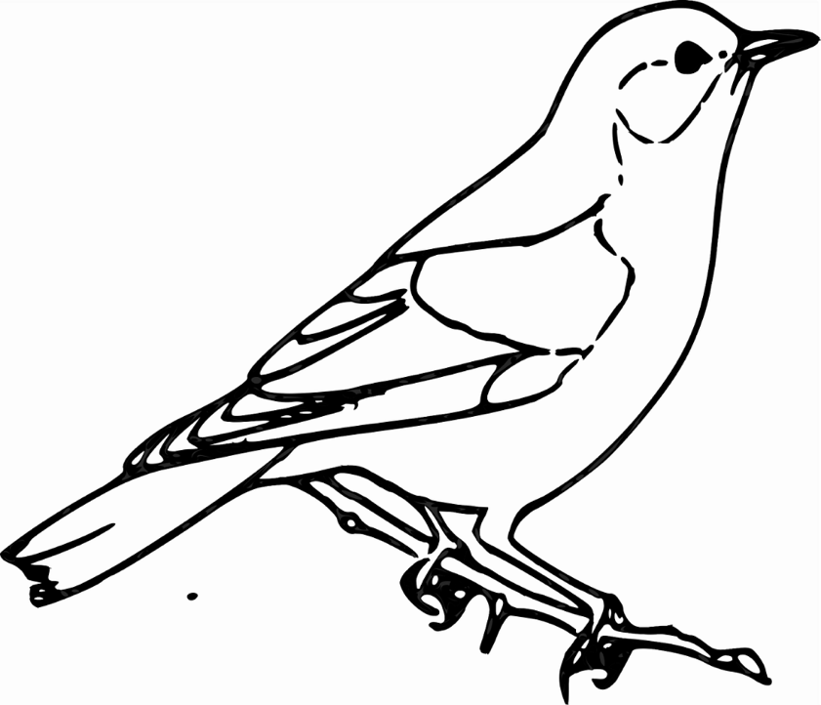

Name: _____________________________________________________________

