Lernbriefkasten Name: __________________

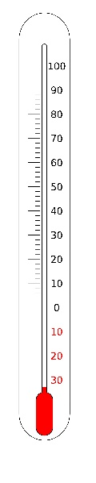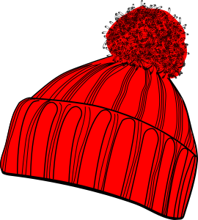

Was wird passieren?

|  |
| --- |
|  |
|  |

Wie erklärst du dir das?

|  |
| --- |
|  |
|  |
|  |
|  |