|  |
| --- |
|  |

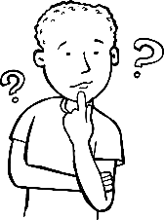Frage:

|  |
| --- |
|  |

Vermutung:

|  |
| --- |
|  |

|  |
| --- |
|  |

Material:

|  |
| --- |
|  |

|  |
| --- |
|  |

Durchführung:

Was machen wir?

|  |
| --- |
|  |

|  |
| --- |
|  |

|  |
| --- |
|  |

|  |
| --- |
|  |



Beobachtung:

Was passiert?

|  |
| --- |
|  |

|  |
| --- |
|  |

|  |
| --- |
|  |

Ergebnis:

|  |
| --- |
|  |