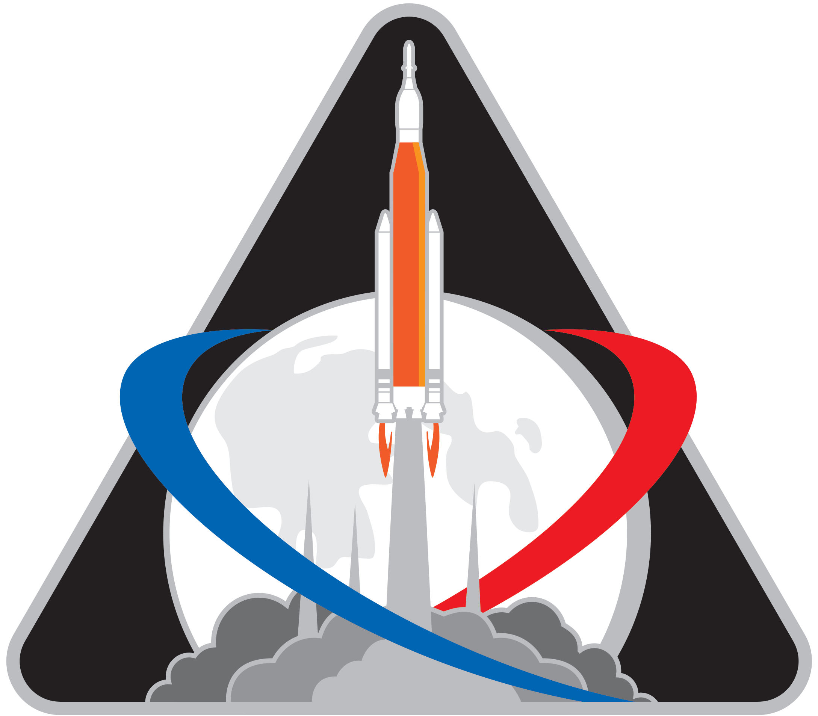Astronaut **Name**

Astronaut **Name**

Astronautin **Sirin**

Astronaut **Nick**

Astronaut **Name**

Astronautin **Name**