

**Forschungsfrage:**

|  |
| --- |
|  |
|  |
|  |
|  |
|  |
|  |
|  |

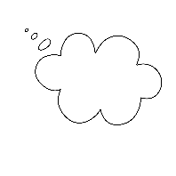

**Vermutung:**

|  |
| --- |
|  |
|  |
|  |
|  |
|  |
|  |
|  |
|  |
|  |
|  |
|  |

Aufbau:

**Versuch planen:**

Das brauche ich:

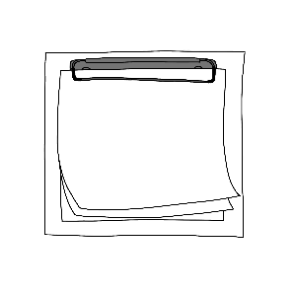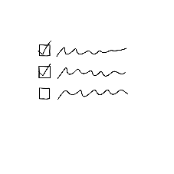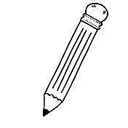

**Beobachtung:**



**Antwort:**

|  |
| --- |
|  |
|  |
|  |
|  |
|  |
|  |
|  |
|  |
|  |
|  |
|  |
|  |
|  |
|  |
|  |